**Chapter 1: Introduction**

**1.1: Brief overview of the work**

We propose to implement a house price prediction model of Bangalore, India. It’s a Machine Learning model which integrates Data Science and Web Development.

**1.2: Objective**

The objective was to forecast the price of a specific apartment based on market pricing while accounting for various “features”.

**1.3: Scope**

This Project will help people who want to buy or sell any properties. It will help people by predicting nearest price of a house according to parameters of that house. So it will help society and also reduce human effort and at the end people will sum up with happiness.

**1.4: Project Modules**

1.4.1: Selecting Dataset.

1.4.2: Data Processing.

1.4.3: Data Transformation.

1.4.4: Selecting Model.

1.4.5: Display the result.

**1.5: Project Hardware/Software Requirements**

1.5.1: Hardware Requirements

* Computer
* Local Server, etc

1.5.2 Software Requirements

* Python Language
* Basic of some libraries
* Django Framework
* GitHub

**Chapter 2: Literature Review**

Real Estate Property is not only a person's primary desire, but it also reflects a person's wealth and prestige in today's society. Real estate investment typically appears to be lucrative since property values do not drop in a choppy fashion. Changes in the value of the real estate will have an impact on many home investors, bankers, policymakers, and others. Real estate investing appears to be a tempting option for investors. As a result, anticipating the important estate price is an essential economic indicator. According to the 2011 census, the Asian country ranks second in the world in terms of the number of households, with a total of 24.67 crores. However, previous recessions have demonstrated that real estate costs cannot be seen. The expenses of significant estate property are linked to the state's economic situation. Regardless, we don't have accurate standardized approaches to live the significant estate property values.

First, we looked at different articles and discussions about machine learning for housing price prediction. The title of the article is house price prediction, and it is based on machine learning and neural networks. The publication's description is minimal error and the highest accuracy. This model is used to identify over a larger spatial scale and implications for the evaluation process related to the selection of comparable evidence and the quality of variables that the values may require. Understanding current developments in house prices and homeownership are the subject of the study. In this article, they utilized a feedback mechanism or social pandemic that fosters a perception of property as an essential market investment.

**Chapter 3: System Analysis & Design**

**3.1 Comparison of Existing Application with our Project**

We used supervised learning algorithms to obtain the highest possible accuracy. The existing applications available in market have hands on a very robust data sources. So they can leverage the data and use more advanced algorithms to get higher accuracy.

**3.2 Feasibility Study**

A feasibility study is used to determine the viability of an idea, such as ensuring a project is legally and technically feasible as well as economically justifiable. It tells us whether a project is worth the investment.

3.2.1 Technical Feasibility:

This assessment focus on technical resource required for this system is available at organization or not. All the necessary technical resource exists at the organization to do what is suggested. An organization has sufficient memory storage available to hold the data required to use this system. After

This system has been developed it can be updated, but it will require someone with technical knowledge. This system also provides security to user’s data.

3.2.2 Operational Feasibility:

This assessment involves undertaking a study to analyze and determine whether and how well the organization’s needs can be met by completing the project. There will be sufficient support for the end user from management.

3.2.3 Economical Feasibility:

This assessment typically involves a cost/ benefits study of the project, helping organizations determine the cost and benefits associated with a project before financial resources are allocated.

As this system is not considered for a business purpose, no any pre-investment is required and also no any benefits has been calculated.

3.2.4 Legal Feasibility:

This assessment investigates whether any aspect of the proposed system conflicts with legal acts.

As this system is not considered for a business purpose, so that all the constraints that has to be followed by an respected organization while developing such system will not be hindrance for developer.

**3.3 Timeline Chart**

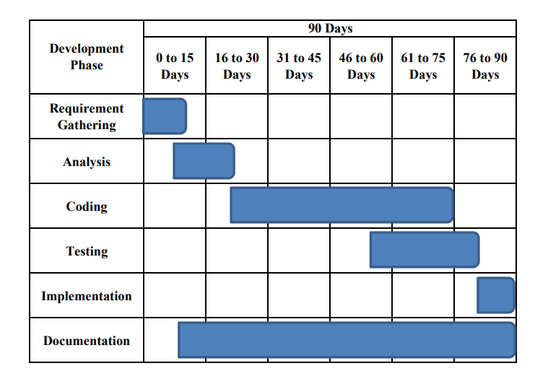 Figure: 3.0 (Time Line Chart)

**3.4 Modules Description**

3.4.1: Selecting Dataset.

* One csv file that contains information about price of a house according to some parameters.

3.4.2: Data Processing.

* After having data in hand, it’s important to pre-process the data to transform raw data in a useful and efficient format.
* Data Cleaning: Dataset can have many irrelevant data and missing parts. So it is required to clean data.
  + Dropping Null values.
  + Filling Null values with mean.

3.4.3: Data Transformation.

* After data cleaning, need to transform data into appropriate form suitable for model training.
* Attribute Selection: In this strategy, new attributes are constructed from given set of attributes to help model.
  + Aggregate function can be used on two or more columns to have new column that may have highly positive or highly negative correlation with target value.

3.4.4: Selecting Model.

* Now data is all set to be trained. But How….??
* So, it is required to select an appropriate training method to train model.
* So, understanding relationship between various set of attributes using histograms, pie charts, bar graphs, etc can help one to select best method to train model.

3.4.5: User Interface.

* One simple website has been created to deploy this model.
* Django framework is used for same.
* Login/Sign Up functionality are there in the website.
* User can easily login and then only he/she will be able to predict price of the house.
* As a database, Django inbuilt SQLite is used.

**3.5 Project SRS**

3.5.1 Use Case Diagram

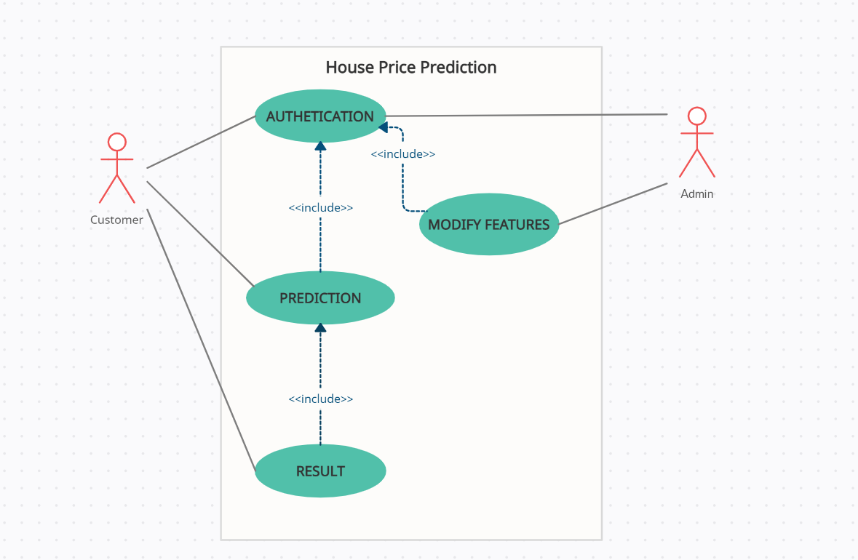

Figure: 3.1 (Use Case Diagram)

3.5.2 Data Flow Diagram

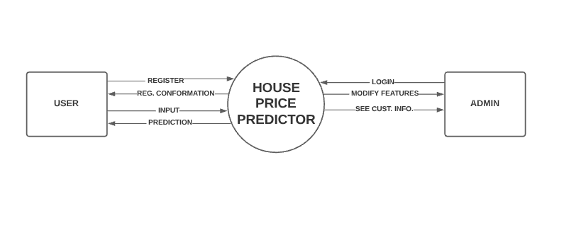

Figure: 3.2 (Data Flow Diagram Level - 0)

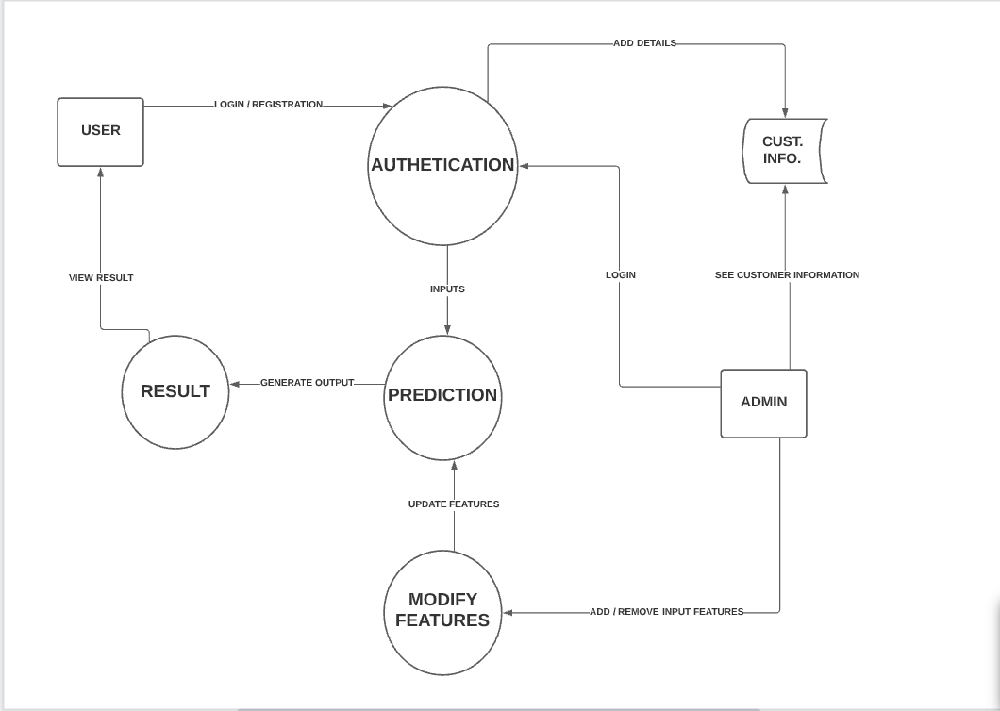

Figure: 3.3 (Data Flow Diagram Level - 1)

3.5.3 Sequence Diagram

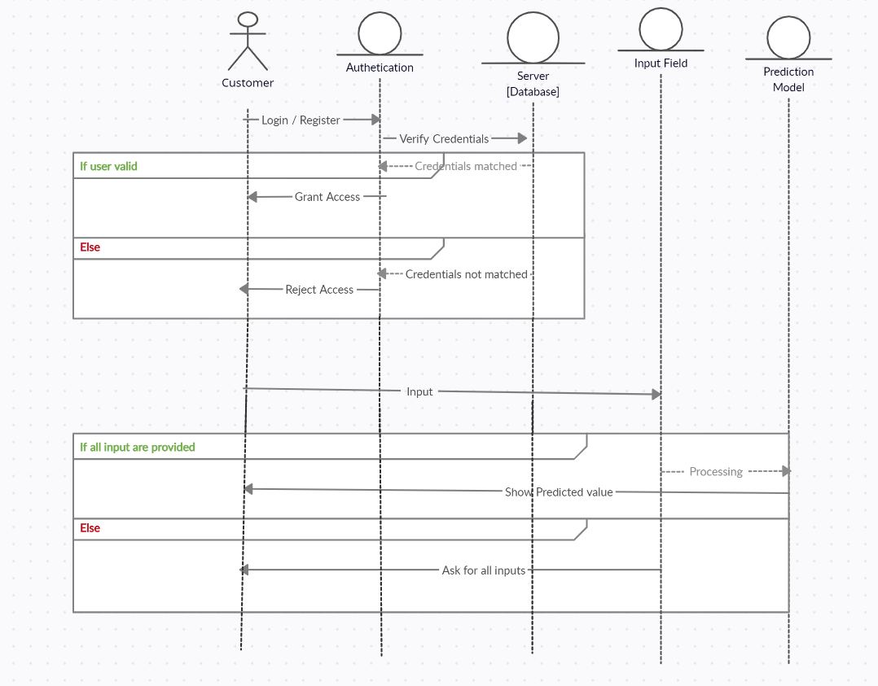

Figure: 3.4 (Sequence Diagram)

**3.6 Data Dictionary**

Table Name:- house_data

Description:- To store data of houses.

|  |  |  |  |
| --- | --- | --- | --- |
| **Sr. No.** | **Column Name** | **Column Type** | **Column Description** |
| 1 | area_type | String | To store type of area in which house in located. |
| 2 | availability | String | To store information regarding availability of house. |
| 3 | location | String | To store location in which house in located. |
| 4 | size | Int | To store size of house (BHK). |
| 5 | society | String | To store society name. |
| 6 | total_sqft | Int | To store total area of house. |
| 7 | bath | Int | To store no of bathrooms in house. |
| 8 | balcony | Int | To store no of balcony in house. |
| 9 | price | Float | To store price of the house. |

Table: 3.1 (house_data)

Table Name:- user

Description:- To store user information.

|  |  |  |  |
| --- | --- | --- | --- |
| **Sr. No.** | **Column Name** | **Column Type** | **Column Description** |
| 1 | username | String | To store username of user. |
| 2 | email address | String | To store email address of user. |
| 3 | first name | String | To store first name of user. |
| 4 | last name | String | To store last name of user. |
| 5 | staff status | String | To store whether user is from staff or not. |

Table: 3.2 (user)

**Chapter 4: Implementation and Testing**

**4.1 User Interface**

4.1.1 Home Page and About Page :--

Description: The very first User Interface in this project is Home page of website. It is a simple static page. It contains images and some quoted text.

Website also contain About page, which has information about all the contributors of this website.

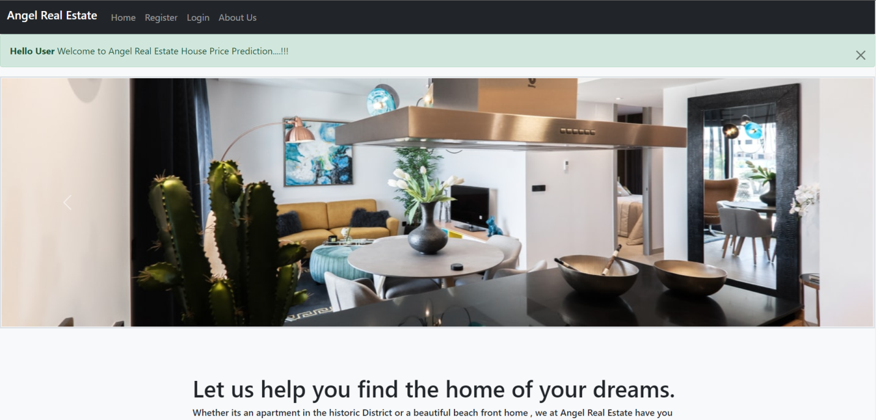

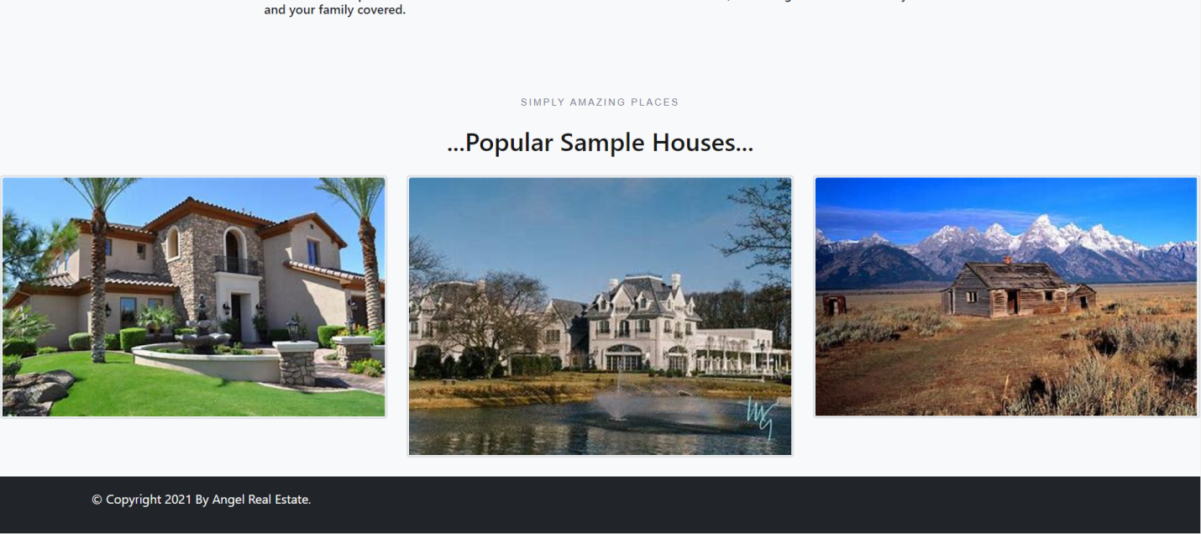

Figure: 4.0 (Home Page)

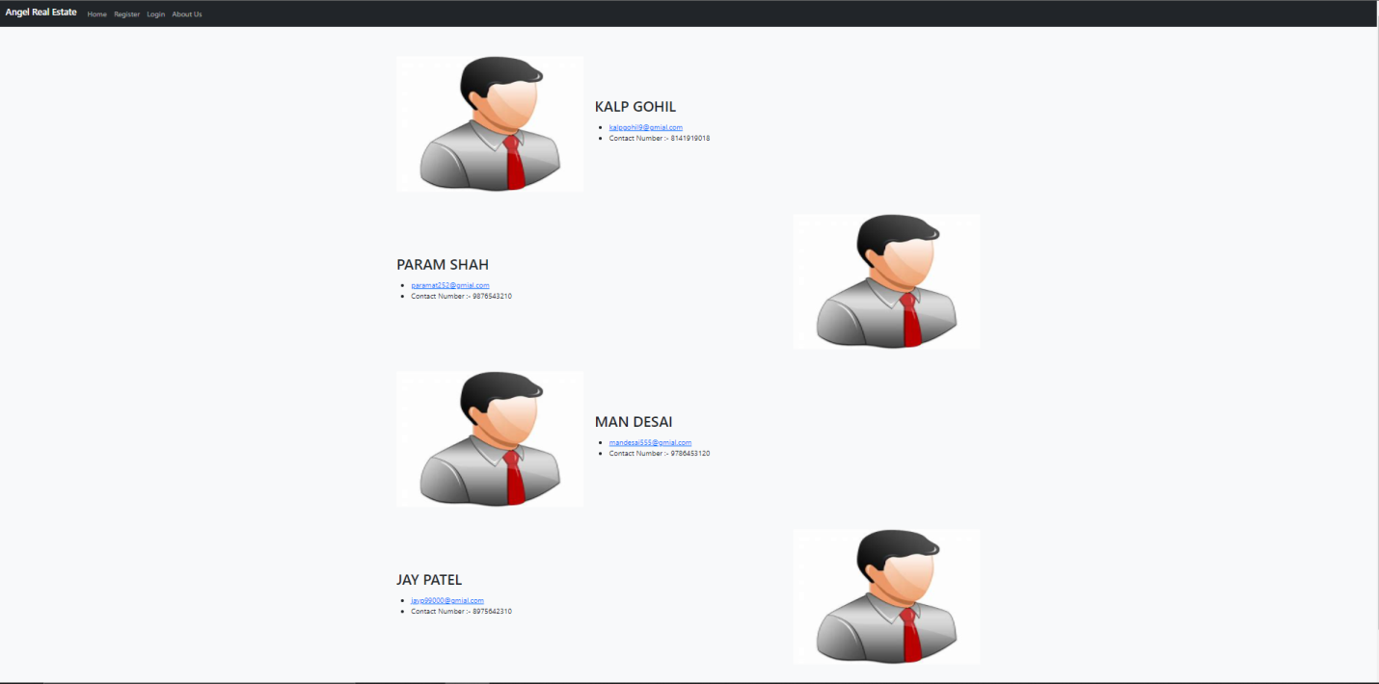

Figure: 4.1 (About Page)

4.1.2 Sign Up/ Login:--

Description: While designing website for any purpose (like for public use or for business part), it is very important to design user sign up page. This will help to analyze our website performance.

In this, it will collect data of the user like first name, last name, email, etc. All this information will be stored in database provided by Django.

If this is a new user, he/she can register on the website and then he/she has all the access to the website. If user is already registered, then he/she can login directly.

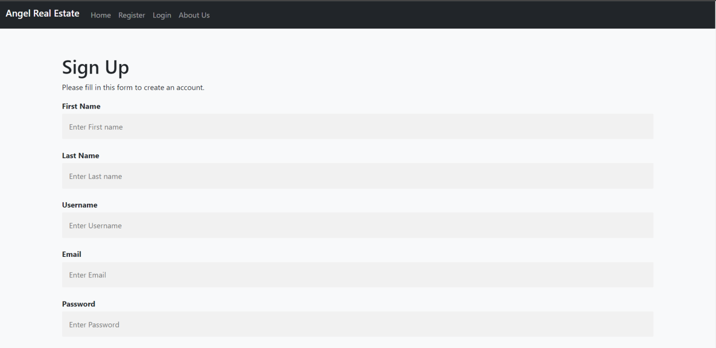

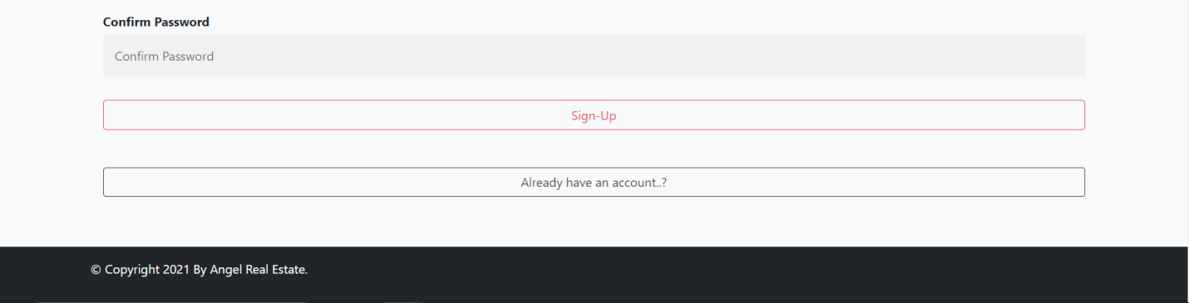

Figure: 4.2 (Sign Up Page)

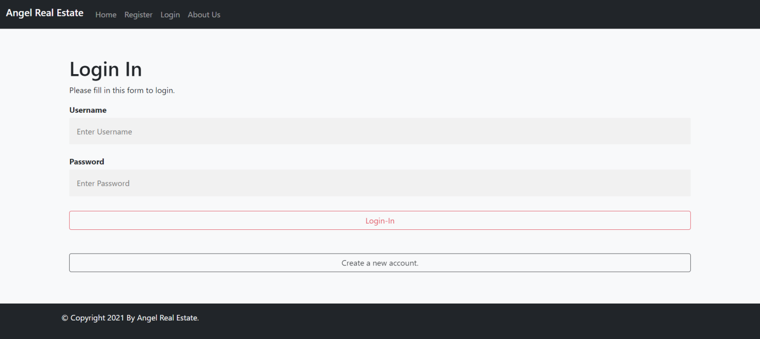

Figure: 4.3 (Login Page)

4.1.3 Prediction Page:--

Description: This page is like heart of the website. In this page there is 4 feature of house that has to be entered by user in order to predict price accordingly.

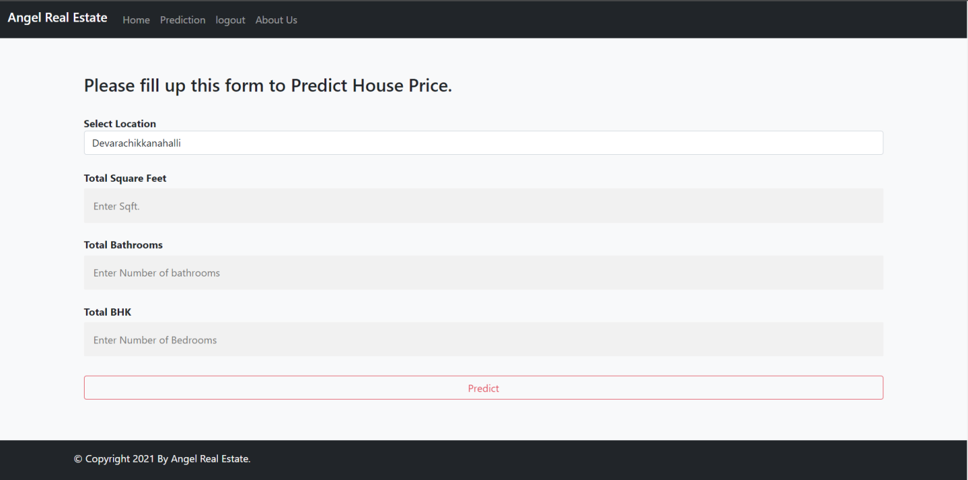

Figure: 4.4 (Prediction Page)

4.1.3 Result Page:--

Description: This page is like heart of the website. In this page there is 4 feature of house that has to be entered by user in order to predict price accordingly.

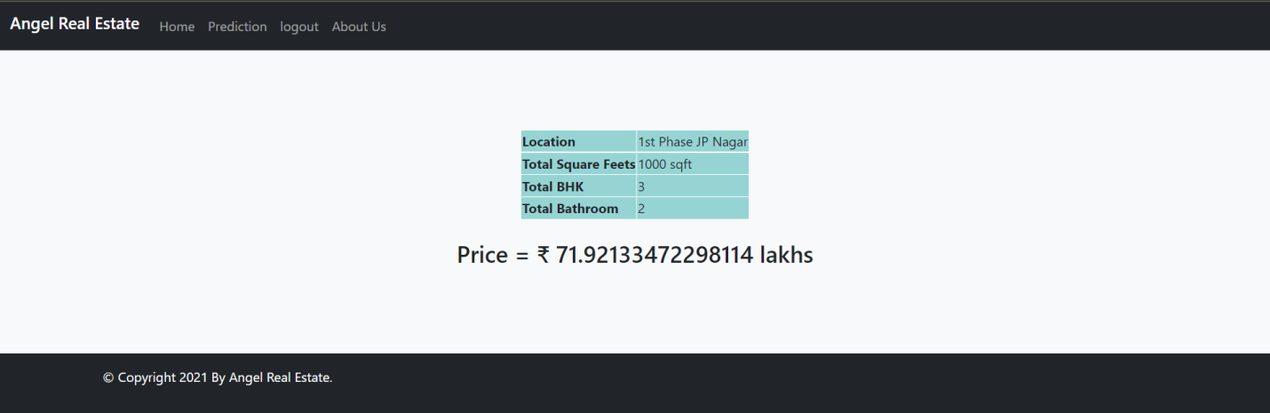

Figure: 4.5 (Result Page)

**4.2 Testing using use cases**

Description: This trained model and website together has been tested on different inputs and it gives desire output.

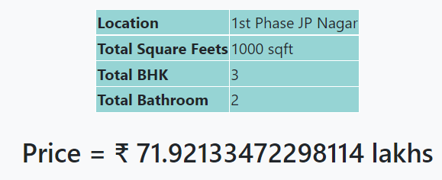 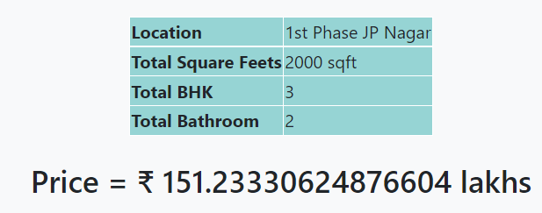

Figure: 4.6 (Test Result 1)

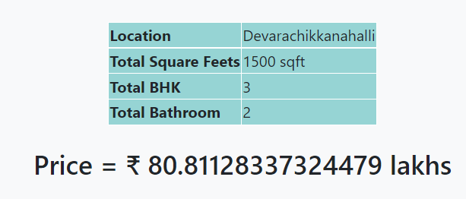 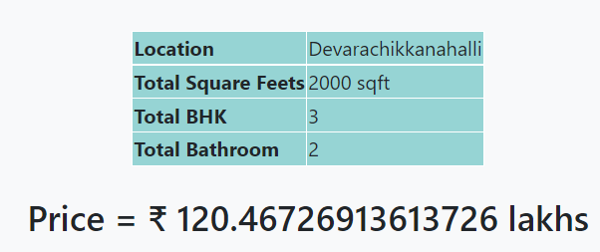

Figure: 4.7 (Test Result 2)

From about, it’s clear that on different parameters, model performs accurately.

**Chapter 5: Conclusion and Future Work**

With several characteristics, the suggested method predicts the property price in Bangalore. We experimented with different Machine Learning algorithms to get the best model. When compared to all other algorithms, the Linear Regression Algorithm achieved the highest accuracy. If only more data was available, we could extend this project to also include advanced algorithms like Artificial Neural Networks (ANN) and other deep learning algorithms. Price prediction can be improved by adding many attributes like surroundings, marketplaces and many other related variables to the houses. The predicted data can be stored in the databases and an app can be created for the people so they would have a brief idea and they would invest the money in a safer way.

**Chapter 6: References**

1. Dataset: [BangloreHousePriceDataset | Kaggle](https://www.kaggle.com/pankajgupta054/banglorehousepricedataset)
2. Django Documentation: <https://docs.djangoproject.com/en/3.2/>
3. GitHub Repository: <https://github.com/kalpgohil7/Group_no_13>
4. YouTube Playlist for Django: <https://www.youtube.com/playlist?list=PLsyeobzWxl7r2ukVgTqIQcl-1T0C2mzau>
5. Book: Kevin Murphy, "Machine Learning: A Probabilistic Perspective", MIT Press, 2012.
6. Book: Tom Mitchell, “Machine Learning”, Indian Edition, Tata McGraw Hill, 2013.